**Performance Testing Using JMETER.**

**Test 1 ->**

* **167 users for 60 sec**
* **Throughput: 2.7 sec**

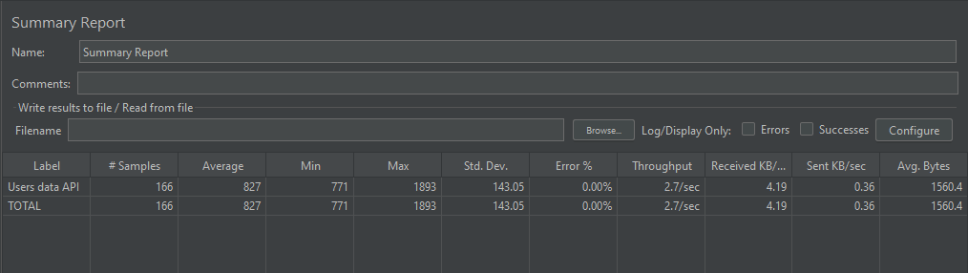

***fig 1: testing 167 users for 60s.***

**Test 2->**

* **833 users for 300 sec**
* **Throughput: 2.8 sec**

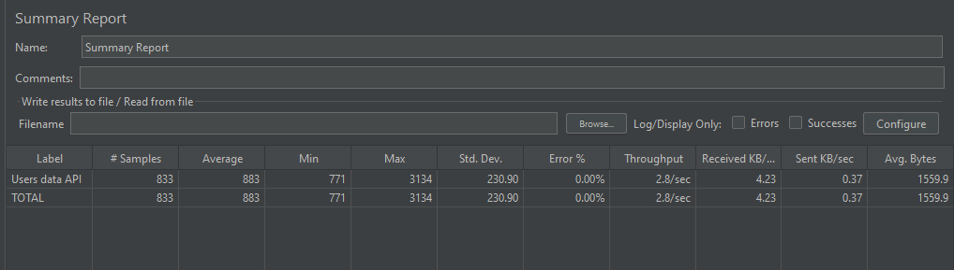

***fig 2: testing 833 users for 300s.***

**Test 3 ->**

* **1667 users for 600 sec**
* **Throughput:2.8 sec**

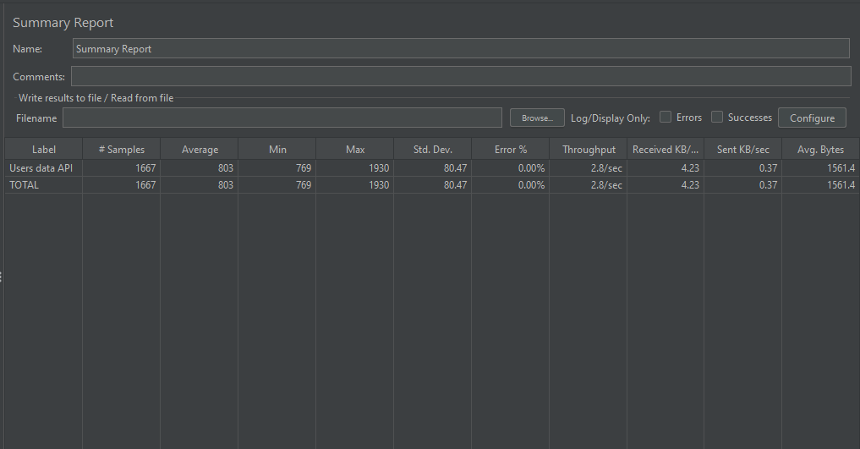

***fig 3: testing 1667 users for 600s***

**Test 4->**

* **2500 users for 900 sec.**
* **Throughput:2.8 sec.**

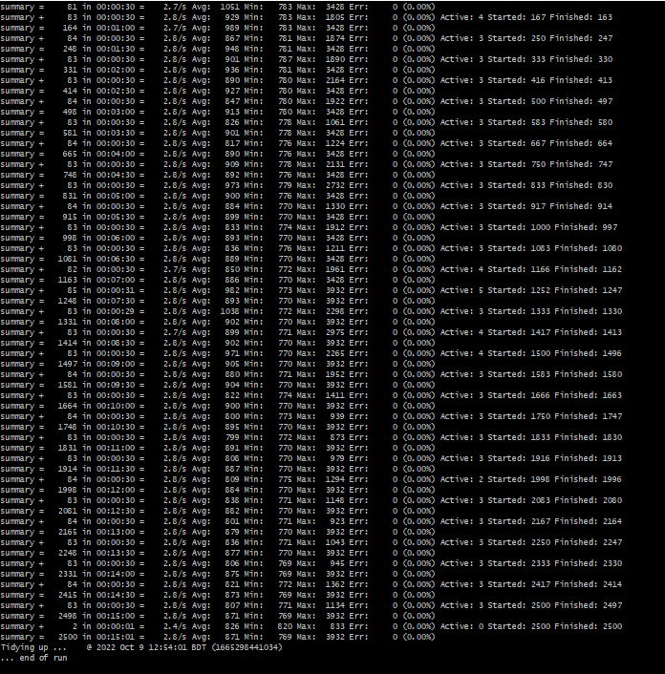

***fig 4: testing 2500 users for 900s***

**Summary report of 2500 users for 900 seconds :**

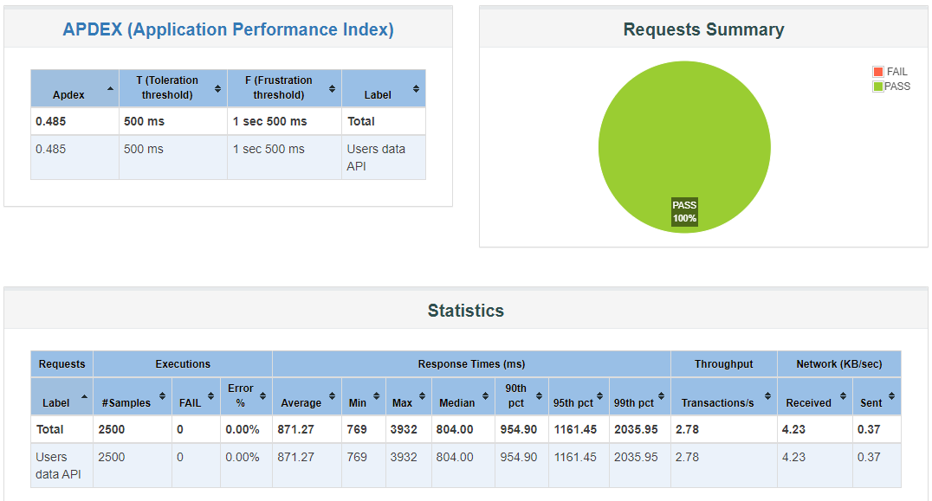

***fig 5: Summary report of 2500 users for 900 s.***